

| Course Number | COE691 |
| --- | --- |
| Course Title | Software Requirements Analysis and SPEC |
| Semester/Year | Winter Semester 2024 |
| Instructor | Dr. Rasha Kashef |
| TA Name | Aman Yadav |

| Lab/Tutorial Report No. | Lab 4 |
| --- | --- |

| Report Title | COE691 Lab 4 |
| --- | --- |

| Section No. | 06 |
| --- | --- |
| Submission Date | Week of March 25, 2024 |
| Due Date | Week of March 25, 2024 |

| Student Name | Student ID | Signature* |
| --- | --- | --- |
| [Hamza Malik](mailto:hamza.ejaz.malik@ryerson.ca) | 501112545 | HM |

*\*By signing above, you attest that you have contributed to this submission and confirm that all work you have contributed to this submission is your work. Any suspicion of copying or plagiarism in this work will result in an investigation of Academic Misconduct and may result in a “0” on the work, an “F” in the course, or possibly more severe penalties, as well as a Disciplinary Notice on your academic record under the Student Code of Academic Conduct, which can be found online at:* [*http://www.ryerson.ca/content/dam/senate/policies/pol60.pdf*](http://www.ryerson.ca/content/dam/senate/policies/pol60.pdf)

**Part I: Context Diagram and DFD**

Case Study: A* Cuisine

**Context Diagram:**

The Context Diagram for the "A* Cuisine System" concisely represents the company's operational interactions. It serves as a crucial tool for comprehending the flow of information that drives the business's operations. The diagram elucidates the interfaces between the system and its external entities—Suppliers, Marketing, and Customers—while delineating the critical data repositories that underpin these interactions. At the system's periphery lie the Suppliers, who are instrumental in providing the essential supplies for A* Cuisine's catering service. The interface with these external entities is managed through the system, enabling the seamless ordering and inventory control that is vital for maintaining service readiness and quality. Marketing efforts are integral to the A* Cuisine brand's proliferation, with the system adeptly managing and tracking the origins of customer engagement. This marketing intelligence, coupled with the identification of repeat customers, allows the company to tailor special offers and reinforce customer loyalty. The system is engineered to actively engage customers, who are essential to the vitality of A* Cuisine. It efficiently records orders, handles special requests, and formalizes contract agreements. The receptionist plays a pivotal role by guiding customers through the system, providing menu details, collecting customer information, completing transactions, and ensuring that customers receive contracts promptly. The Owner's interaction with the system is a testament to its flexibility and utility. It serves as an administrative nexus from which the Owner orchestrates supply orders based on weekly event schedules, responds to particular customer requests with cost estimations, and tracks the status of contracts and bookings. Three cornerstone databases support the vast array of operational demands: the Customer Database, the Order Database, and the Inventory Database. These repositories are meticulously designed to capture comprehensive datasets—from customer details and marketing analytics to nuanced order specifications and inventory metrics. The Customer Database is a repository of client information and marketing data. It secures customer particulars and enables A* Cuisine to monitor the efficacy of its marketing strategies and understand customer acquisition channels. The Order Database is an archival and retrieval hub for all catering orders, storing critical event information such as dates, venues, selected menus, and pricing agreements. The Inventory Database is a testament to the company's commitment to supply chain precision, housing intricate inventory details that foster informed and timely ordering from suppliers. The operational workflows depicted in the context diagram signal a paradigm shift in how A* Cuisine will navigate its business processes. The receptionist, acting as the liaison between customers and the system, captures the dynamic nature of customer interactions—from initial inquiries to the complexities of custom requests and contract finalization. Marketing strategies are informed and evolved through the insights gleaned from the system, while the Owner's role in supply ordering and cost management is streamlined for efficiency. 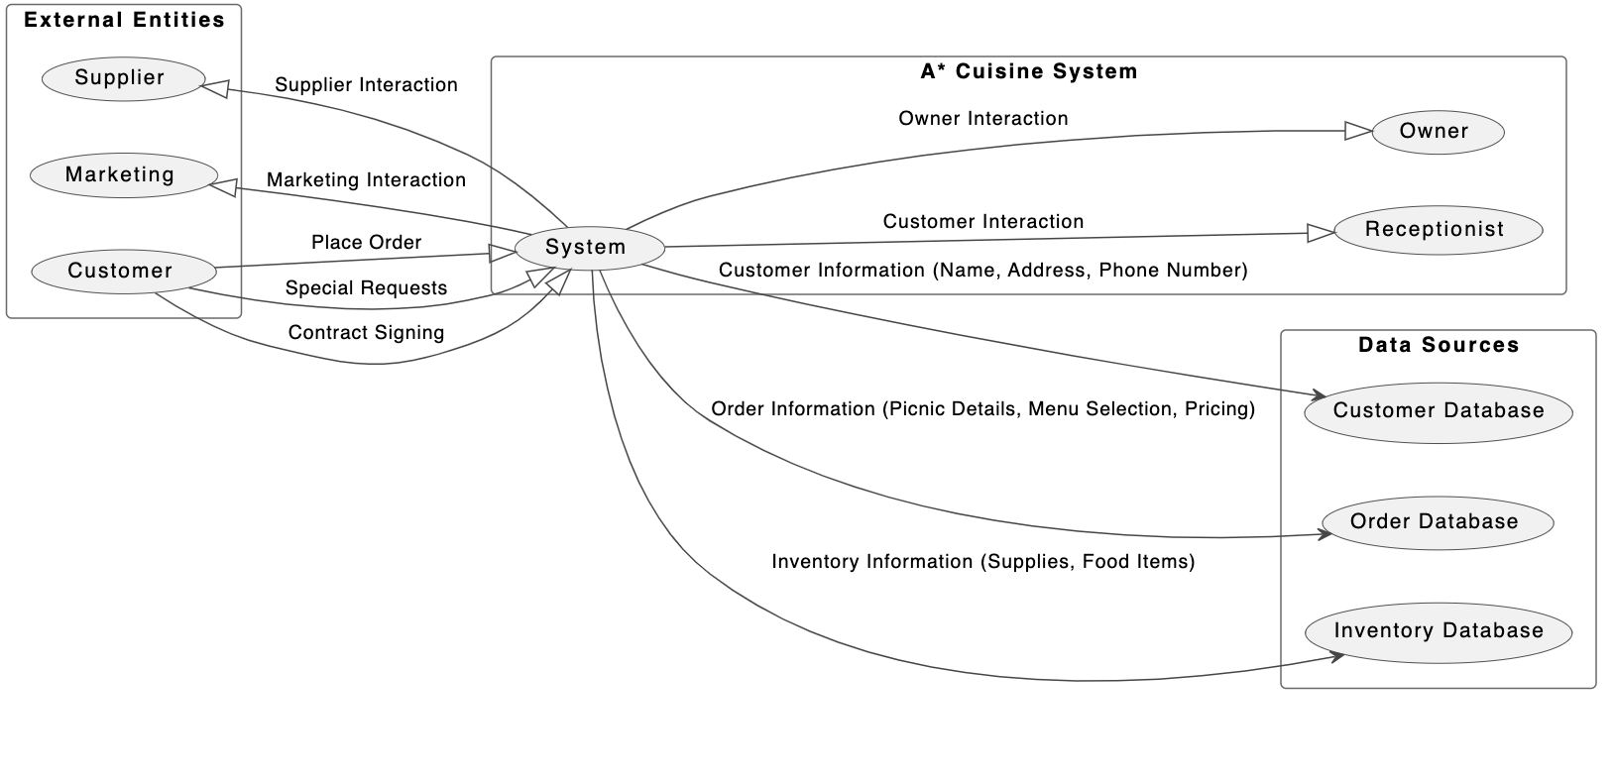

**DFD Diagram Level 0:**

The Level 0 Data Flow Diagram (DFD) for the A* Cuisine system provides a strategic overview of the high-level data processing activities. It illustrates the system's interactions with external entities and internal data stores. The A* Cuisine System is central to the diagram, a singular process hub encompassing vital operational functions such as Order Processing, Inventory Management, Customer Relationship Management, Marketing and Promotions, and Delivery Coordination. This central process indicates that the system is conceptualized as a monolithic entity with interconnected internal functions at this stage. External entities interact with the A* Cuisine System in a manner that defines the system's scope and the nature of data exchanges. The Customer entity, for example, is a primary initiator of data flow, engaging with the system to place orders, seek information, request special services, and provide feedback. In return, customers receive promotional communications and order confirmations, which signifies a responsive and interactive relationship with the system. The Owner entity's role is to obtain reports and analytics that provide valuable business insights, demonstrating a top-down flow of information supporting strategic business decision-making. The Supplier entity plays a critical role in the supply chain, managing the inflow of inventory data to the system and responding to inventory orders, thereby maintaining efficient stock levels. Third-party delivery services represent the logistics component of the system, which is involved in coordinating delivery orders and updating delivery status, ensuring a seamless operational flow from order processing to the physical delivery of goods. As an external entity, marketing interacts bidirectionally with the system by contributing marketing insights and retrieving data for strategy formulation and campaign performance analysis. Integral to the system's functionality are the data stores: the Customer Database, Order Database, Inventory Database, Delivery Database, and Marketing Database. Each serves as a repository for specific categories of information, ranging from personal customer data and order specifics to inventory statuses, logistical details, and marketing data. The explicit labelling of data flows like 'Update Customer Info,' 'Record Orders,' 'Update Inventory,' 'Log Delivery Info,' and 'Store Marketing Data' clarifies the information exchanged and the actions performed within the system. Designed to present a clear and comprehensive view of the A* Cuisine System's data flow architecture, this DFD Level 0 effectively communicates with stakeholders, offering an overarching perspective on operations and data management. It sets a foundation for subsequent detailed analyses and DFDs to further dissect the A* Cuisine System's operations, providing deeper insights into each specific process.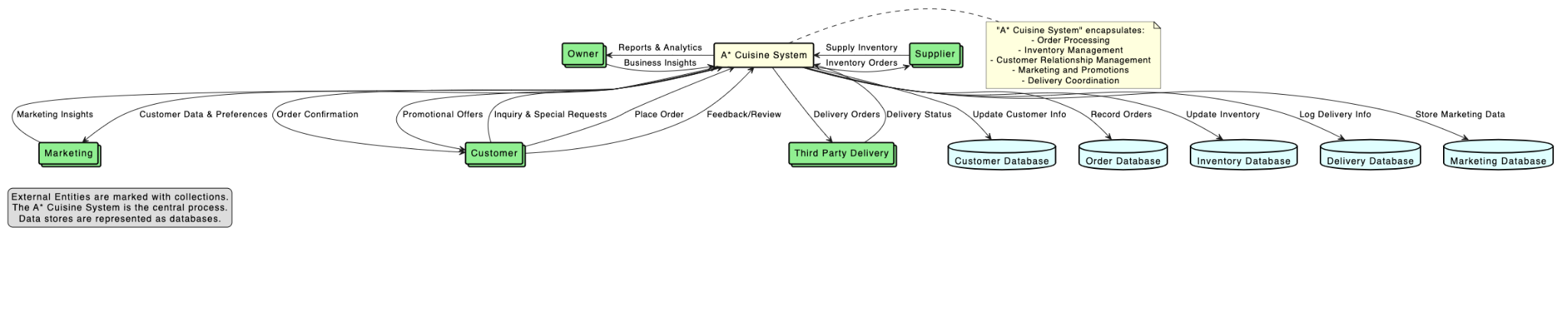

**Part II: Entity Relationship Diagram**

Case Study: Express Burger Restaurant 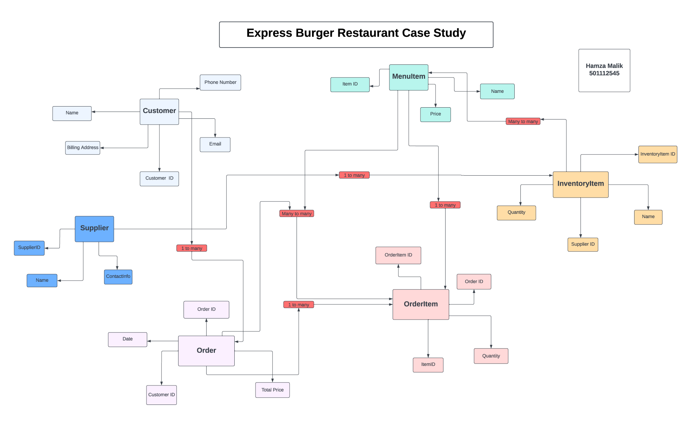

The Entity-Relationship Diagram (ERD) for Express Burger Restaurant systematically represents its operational data structure, offering a concise yet comprehensive blueprint for the database needed to support its business processes. In the ERD, each entity corresponds to a real-world object or concept relevant to the restaurant's operations, and the relationships between these entities illustrate how data will flow and interconnect within the restaurant's information system. Central to the ERD is the 'Customer' entity, reflecting the importance of customer information in the operational model. Attributes such as Name, Phone Number, Billing Address, and Email provide a multifaceted view of the customer, crucial for personalized service delivery and marketing efforts. The 'CustomerID' is a unique identifier that facilitates tracking individual customer interactions, preferences, and transaction history. It enables the restaurant to build a customer-centric approach, which is essential in the hospitality industry. Adjacent to 'Customer' is the 'Order' entity, which captures critical transactional data, including the date, total price of the order, and a link back to the customer through 'CustomerID.' This entity is instrumental in tracking sales, analyzing revenue streams, and understanding purchasing patterns over time. At the heart of the transactional process is the 'OrderItem' entity. This associative entity bridges the gap between 'Order' and 'MenuItem,' allowing for a granular breakdown of orders into individual items and quantities. The 'OrderItem' entity is essential for detailed order management, ensuring accuracy in order fulfillment and inventory depletion.

The 'MenuItem' entity contains the list of items available for order at the restaurant, with each item having its own 'ItemID' and 'Price.' This setup facilitates menu management and enables dynamic pricing strategies and customization based on customer demand and ingredient availability. On the supply side, the 'Supplier' entity is connected to 'InventoryItem,' demonstrating the one-to-many relationship that portrays the sourcing of multiple inventory items from individual suppliers. This connection is pivotal for supply chain management, allowing the restaurant to monitor stock levels, track deliveries, and maintain relationships with multiple suppliers. The 'InventoryItem' entity is directly linked to the restaurant's operational efficiency. It maintains records of stock quantities, which are vital for day-to-day operations and financial planning. By keeping an up-to-date inventory, the restaurant can minimize waste, optimize ordering, and ensure that customer orders are fulfilled promptly and accurately. The ERD encapsulates the intricate relationships within Express Burger Restaurant's operational framework. It is a crucial tool for Mike and Judy Stone as they transform their business processes from paper-based to sophisticated computerized systems. The ERD not only provides a visual aid for database design but also serves as a strategic instrument for business analysis and decision-making.

**1. Based on the information provided in the previous scenario in italics, what entities will Express Burger need to store information about?**

**Entities Required by Express Burger**

* Express Burger's operational efficiency is contingent on effectively managing various data types represented by entities in the ERD. Firstly, the 'Customer' entity is paramount, housing critical data for consumer management and enabling the restaurant to offer personalized service and cultivate customer loyalty. The 'Order' entity is equally essential, capturing all sales transactions, which are the lifeblood of the restaurant's revenue stream. Next, the 'OrderItem' entity plays a critical role as an intermediary between 'Order' and 'MenuItem,' detailing the composition of each order. 'MenuItems,' the essence of any restaurant, form the entity where each item's identity and pricing information is stored. This allows for precise control over the menu offerings, including cost analysis and menu development based on customer preferences and profitability assessments. Furthermore, the 'Supplier' entity is fundamental to supply chain management, enabling the restaurant to maintain an organized record of suppliers and streamline the procurement process. Finally, the 'InventoryItem' entity is crucial for inventory management, a cornerstone for operational logistics, ensuring that the right ingredients are available at the right time to meet customer demand. Each entity is interdependent, collectively supporting the restaurant's objective to deliver quality service while maintaining operational efficiency.

**2. For the entities identified in the previous part, identify a set of attributes for each entity as well as specify an identifier for each entity.**

**Attributes and Identifiers for Entities**

* In database design, attributes are the properties or characteristics of an entity that provide detailed information about it. At the same time, identifiers are unique attributes that unequivocally distinguish each instance of the entity. In the context of Express Burger, attributes are carefully selected to capture all necessary information required for a smooth operation and meaningful customer interactions. For instance, the 'Customer' entity includes contact details and billing information, essential for order processing and marketing activities. The 'CustomerID' serves as a unique identifier, facilitating a reliable reference point for all customer-related transactions. 'Order' holds transactional attributes such as the date and total price, while 'OrderID' uniquely identifies each sale. 'MenuItem' and 'InventoryItem' entities have 'ItemID' as their unique identifier, allowing for precise tracking and management of menu offerings and inventory stock. The 'OrderItem' entity, pivotal in the many-to-many relationship between 'Order' and 'MenuItem,' includes 'OrderItemID' as its unique identifier and additional attributes like quantity to detail the specific items within each order. Identifiers are chosen based on the rule of uniqueness and permanence. They must be inherently unique to avoid ambiguity, and their immutability over time is preferred to maintain data integrity. System-generated identifiers, such as sequential numbers or GUIDs, are often employed to ensure these criteria are met, establishing a robust foundation for database relations and operations.

**3. What rules did you apply when selecting the identifier?**

**Rules Applied When Selecting Identifiers**

* Selecting identifiers for entities within the ERD for Express Burger follows stringent rules to ensure data integrity and ease of database management. The primary rule is the enforcement of uniqueness; each identifier must be distinctive to each record within its entity, allowing for unambiguous identification and retrieval of information. This uniqueness is critical, especially when similar attributes, such as names, may be duplicated. The second rule is immutability, where identifiers, once assigned, should not change. This stability prevents referential integrity issues where related records might become orphaned due to identifier alterations. Using system-generated identifiers, such as auto-incrementing primary keys, is a common approach to satisfying these rules. It removes the risk of human error in manually assigning identifiers and guarantees that each new record will have a unique, immutable identifier. For the Express Burger, identifiers like 'CustomerID,' 'OrderID,' and 'ItemID' likely follow this auto-incrementing pattern, ensuring each customer, order, and item can be individually referenced and traced through the system without conflict or confusion. In applying these rules, it's also essential to consider the scope and scale of the database. For small businesses like Express Burger, numerical identifiers are typically sufficient. However, more complex identifiers, such as UUIDs, may be necessary for larger systems to handle the greater volume and variety of data. The selected identifiers thus balance the database's current needs and potential growth, ensuring scalability and flexibility for future business expansion.

**4. Draw the entity relation diagram and be sure to specify the cardinalities for each relationship**

**Entity Relation Diagram and Cardinalities**

* The ERD is a visual representation that details the entities within Express Burger's database and the relationships between them, with cardinalities defining the nature and extent of these relationships. Cardinality specifies the number of instances of one entity that can or must be associated with each instance of another entity, thereby guiding the database design to ensure proper data structure and relationships. The relationships represented in the ERD are essential for accurately modelling business processes. The one-to-many relationship from 'Supplier' to 'InventoryItem' reflects that a single supplier can provide numerous inventory items, but each item comes from only one supplier. Similarly, the one-to-many cardinality between 'Customer' and 'Order' allows tracking multiple orders placed by a single customer over time, enabling analysis of customer behaviour and order history. The many-to-many relationship between 'Order' and 'MenuItem' via the 'OrderItem' associative table is particularly crucial. It allows for the flexible combination of menu items within orders, reflecting the diverse selections that customers can make. This relationship's representation in the ERD is facilitated by denoting 'OrderItem' with a separate entity box connected to both 'Order' and 'MenuItem' with lines ending in crow's foot notations, signifying the diversity of the relationship.

**Part III: State Machine Diagram Draw a state machine diagram for the job Application below**

Case Study: Job Application

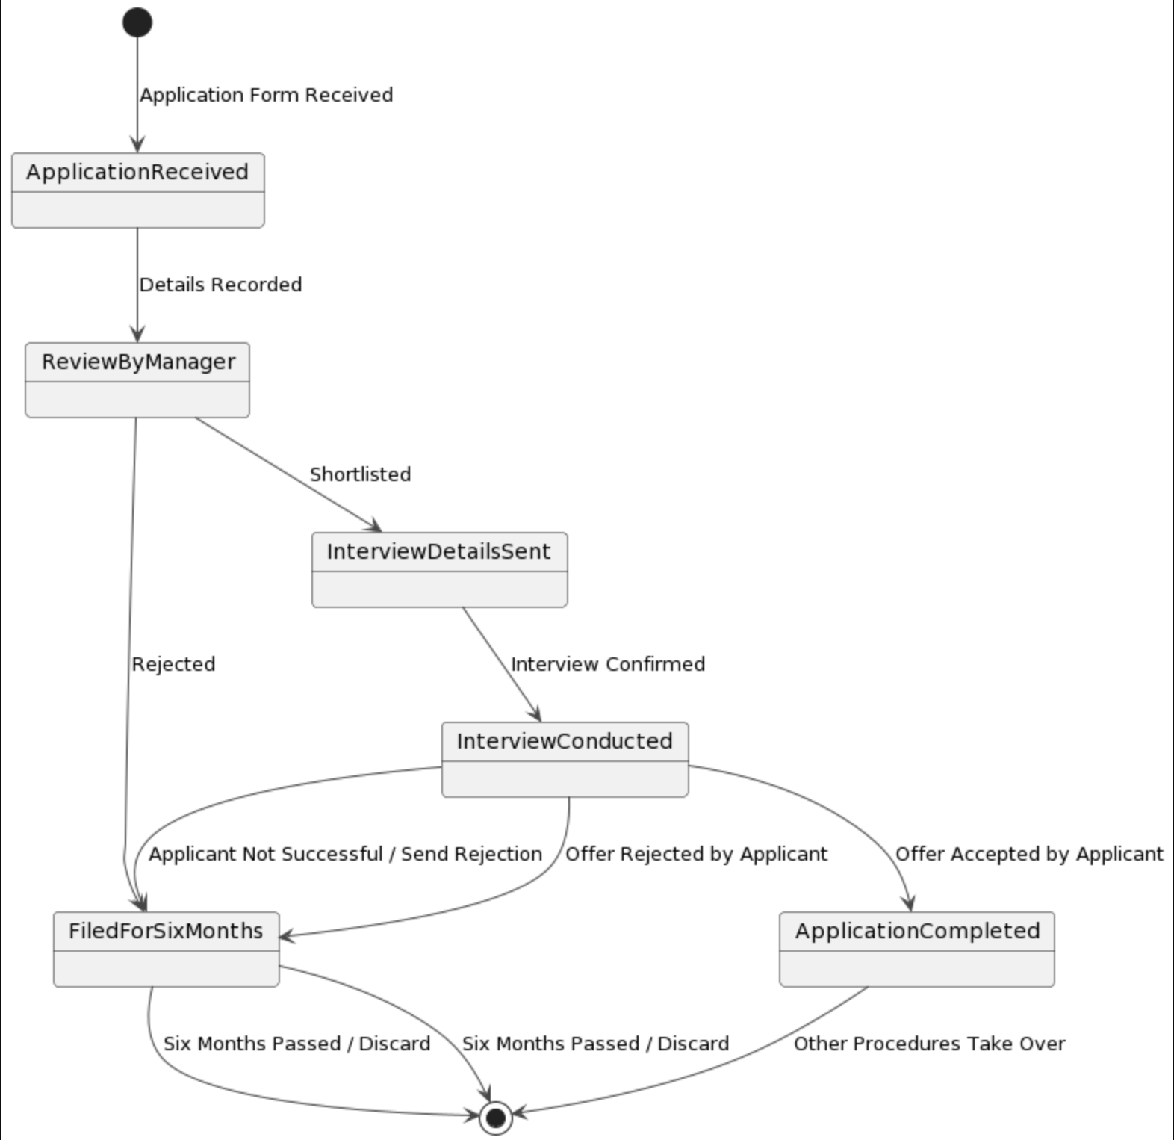

The state machine diagram presented captures the lifecycle of a job application process in a structured and detailed manner. The diagram serves as a visual guide to the states through which a job application can transition, from its inception to conclusion, providing clarity on the workflow and decision points within a typical hiring framework. The process is initiated when an application form is received, transitioning the state from the initial point to "Application Received." This state is fundamental as it represents the entry point into the system for every potential candidate. The following state, "Details Recorded," signifies recording the applicant's details into the company's system—a procedural step for documentation and future reference. The diagram then delineates a critical junction: the "ReviewByManager" state. Here, a manager reviews the application, which can lead to two possible pathways: shortlisting or rejection. The bifurcation of the flow at this stage underscores the significance of managerial assessment in the selection process. If an application is shortlisted, it progresses to the "InterviewDetailsSent" state. This transition indicates the proactive engagement of the employer, moving the applicant closer to the possibility of employment. The "Interview Conducted" state follows, contingent upon the applicant confirming the interview details. The outcomes post-interview are pivotal, with three potential transitions: if the applicant is not successful or if they reject the offer, the application is moved to the "FiledForSixMonths" state; if the applicant accepts the offer, the process culminates at the "ApplicationCompleted" state, indicating a successful hire. The "FiledForSixMonths" state encapsulates a holding pattern for applications that are either rejected by the manager, by the applicant post-interview or when an applicant is unsuccessful. It is a retention state, suggesting that applications are kept on file for potential future consideration, highlighting the organization's resourcefulness and potential for revisiting past candidates. The consistent transition from this state to the termination point after six months implies a systematic archival process, ensuring that the application does not indefinitely occupy active space within the system. The state machine diagram functions as a systematic map, outlining the sequential flow and possible transitions a job application can undergo within the organization's hiring procedure. It reflects the organization's systematic approach to talent acquisition, from the receipt of the application to the final disposition of the applicant's status. The diagram efficiently communicates the company's operational norms and decision-making criteria, serving as a tool for applicants and hiring managers to understand the job application journey within the system. Additionally, with its clear and linear transitions, the diagram's structure enables stakeholders to anticipate outcomes and prepare accordingly. It provides a reference point for the human resources department to standardize the application process, ensuring a consistent and fair evaluation for all candidates. This process transparency is vital for internal auditing and providing candidates with insights into the hiring timeline and criteria. The state machine diagram, therefore, is more than just a flowchart; it is a manifestation of the organization's commitment to a structured, transparent, and fair hiring process. It provides a blueprint to be followed, audited, and improved upon, reflecting a dynamic interplay between organizational needs and applicant engagement in the recruitment lifecycle.